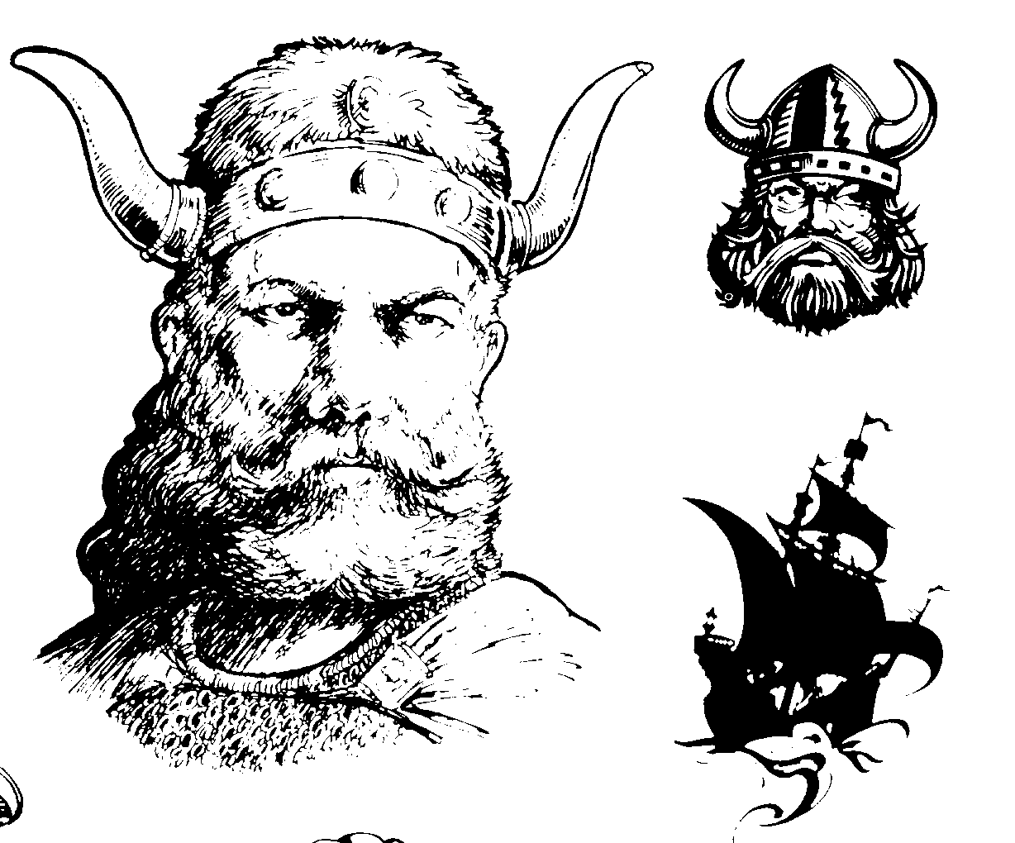

Second Generation
Norwegian American
2nd Daughter of Hans T. Fortney

Name: Tonetta Marthia (Nettie) Fortney
B/Plc: 6 April 1893; Viroqua, WI
D/Plc: 16 January 1988, Menomonee, WI
Occupation: Housewife, Mor

Name: Rev. Frederick Dahl
B/Plc: 14 September 1890; Glenwood City, WI
D/Plc: 21 November 1977; Menomonie, WI
Occupation: Lutheran Minister

Married: September 1918
Place: Wheeler?

Fred & Nettie Dahl
5 children, 1 living;
14 grand children.

[ II ] Family Tree Branches: Tonetta Marthia Fortney Dahl

Name: Gilroy
B/Plc: 12 July 1931; Baldwin, WI
D/Plc: 1981
Occupation:
S/C:

Name: Frederick
B/Plc: 10 September 1923; Mott, ND
D/Plc:
Occupation:
S/C:

Name: Monrad “Doc”
B/Plc: 28 August 1921;Mott, ND
D/Plc:
Occupation: Physical Therapist
S/C:

Name: Adrian Hilman Dahl
B/Plc: 6 December 1919; Mott, ND
D/Plc:
Occupation: Nuclear Physicist, Professor
S/C:

Name: Sylvia
B/Plc: 25 February 1926;Hastings, ND
D/Plc:
Occupation:
S/C: Warren Kromroy: 1 son [Richard Goll]



[ III ] Family Tree Branches: Frederick Dahl

Third Generation Norwegian American
Son of Tonetta Marthia [II] (“Nettie”) & Frederick Dahl

Name: Frederick
Born: 10 September 1923
Deceased:
Occupation:

Name: Rosemary
Born:
Deceased:
Occupation:

Married:
Place:

Name: Tolana Marie
B/Plc: 28 January 1950
Occupation:
S/C: Charles Brown; 1 dau. (Deanna)

Name: Randi Elizabeth
B/Plc: 25 November 1953
Occupation:
S/C: unknown

Name: Frederick Thomas
B/Plc: 25 May 1951
Occupation: military
D/Plc: when/where in service?

Name: Steven Kendal
B/Plc: 25 March 1955
Occupation:
S/C: Sylvia; 1 son (Tommie)

Name: Edward Luke Dahl
B/Plc: 19 August 1951
D/Plc: 31 July 1969
Occupation: Tractor accident on a farm
S/C: none/none

[ III ] Family Tree Branches: Sylvia Dahl Kromroy Goll

Name: Sylvia Dahl Kromroy Goll
B/Plc: 25 February 1926; Baldwin WI
D/Plc
Occupation:

Married:
Place:

2 children: 3 grandchildren

Name: Warren Kromroy
B/Plc: 1980
D/Plc:
Occupation

Third Generation Norwegian American
Daughter of Tonetta Marthia [II] (“Nettie”) Fortney & Frederick Dahl

Married:
Place:

Name: Richard Goll
B/Plc:
D/Plc: 11 May 2005; Huntington, PA
Occupation:

Name: Tom William Kromroy
B/Plc: 26 September 1951
D/Plc:
Occupation:
S/C:Kathy

Name: Marie Jean
B/Plc:
D/Plc:
S/C:



[ Generation IV] : Family Tree Branches & Twigs

Fourth Generation Norwegian American
3. The Nettie Fortney Dahl Clan;
Children of Sylvia & Warren Kromroy

Name: Tom Kromroy]
B/Plc: [date born and where]
D/Plc: [date of death and place]
Occupation:

Name: Kathi Kromroy
B/Plc: [date born and place]
D/Plc: [date of death and place]
Occupation:

Married: [date]
Place: [town]

Name: Andrew
B/Plc:
D/Plc: [death/place – hopefully left blank]
Occupation:
S/C: spouse & children

Name: Sarah
B/Plc:
D/Plc:
Occupation:
S/C:

Name: Anna
B/Plc:
D/Plc:
Occupation:
S/C:

